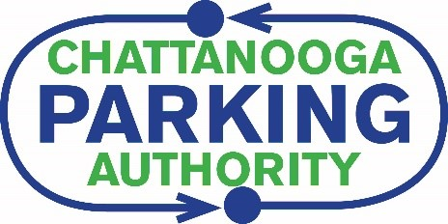

APPLICATION FOR RESTRICTED ON-STREET PARKING

**FORT NEGLEY HISTORIC DISTRICT**

**PERMIT EXPIRES JUNE 30, 2022**

**NAME:**

**FORT NEGELY ADDRESS:**

**MAILING ADDRESS:**

**EMAIL ADDRESS:**

**\*IF YOUR CAR IS NOT REGISTERED AT THE FORT NEGLEY ADDRESS, YOU MUST SHOW A COPY**

**OF YOUR LEASE AGREEMENT OR A PIECE OF MAIL WITH PROOF OF ADDRESS\***

**DAYTIME TELEPHONE NUMBER:**

**CAR MAKE/MODEL: YEAR:**

**COLOR: LICENSE PLATE NUMBER: STATE:**

***Permits are issued to residents on Mitchell Avenue between East 16th Street to East 19th Street, Read Avenue between Rossville Avenue to East 19th Street, East 16th between Underwood Street and Mitchell***

***Avenue, and East 17th Street from Underwood Street to Capella Street.***

***Residences will be Allowed a MAXIMUM of 3 Permits per Address.***

***Residences Refer to both Single Family and Multiple Occupancy Units*.**

**APPLICANT SIGNATURE: DATE:**

**NUMBER on PERMIT (sticker): GUEST PASSES? (MAX 2): NUMBER(S):**

1362 Market Street Chattanooga, TN 37402 Phone: 423-648-4031 klewis@chattanoogaparking.org