Xplor Rec Software
User Manual

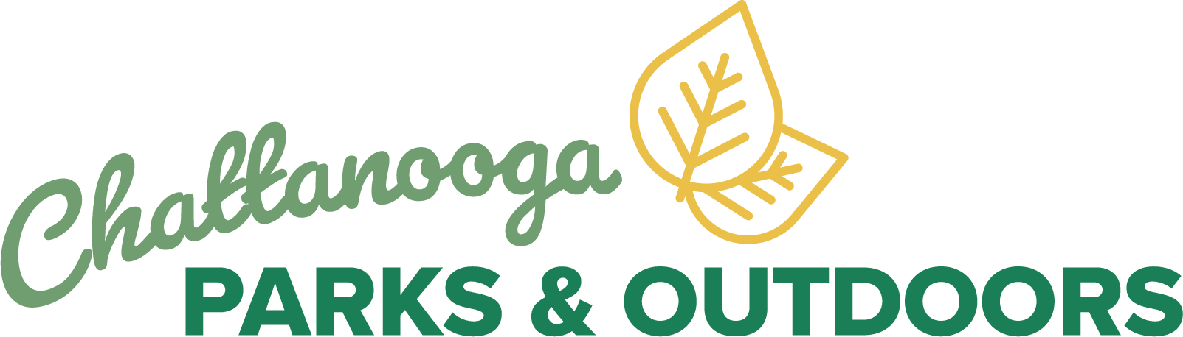

Xplor Rec Software User Manual

Table of Contents

Getting Started ...................................................................................................................... 3
Account ............................................................................................................................ 3
Dashboard ........................................................................................................................ 7

Xplor Rec Software User Manual

Getting Started

Welcome to the City of Chattanooga Department of Parks and Outdoors online reservation and registration of programs and events. Please go online to chattanooga.perfectmind.com and review the initial instructions on the homepage. In order to proceed, you will need to sign up for an account.

Account

You must create an account to view/register for programs and events and reserve facilities.
1. Click on Signup next to Don’t have a login.

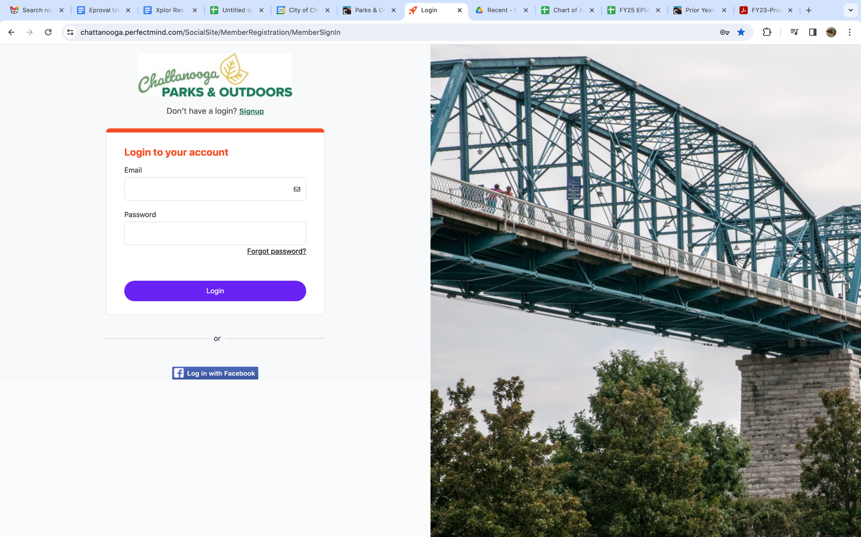

Xplor Rec Software User Manual

2. Fill out all information. ALL Required fields must be filled.

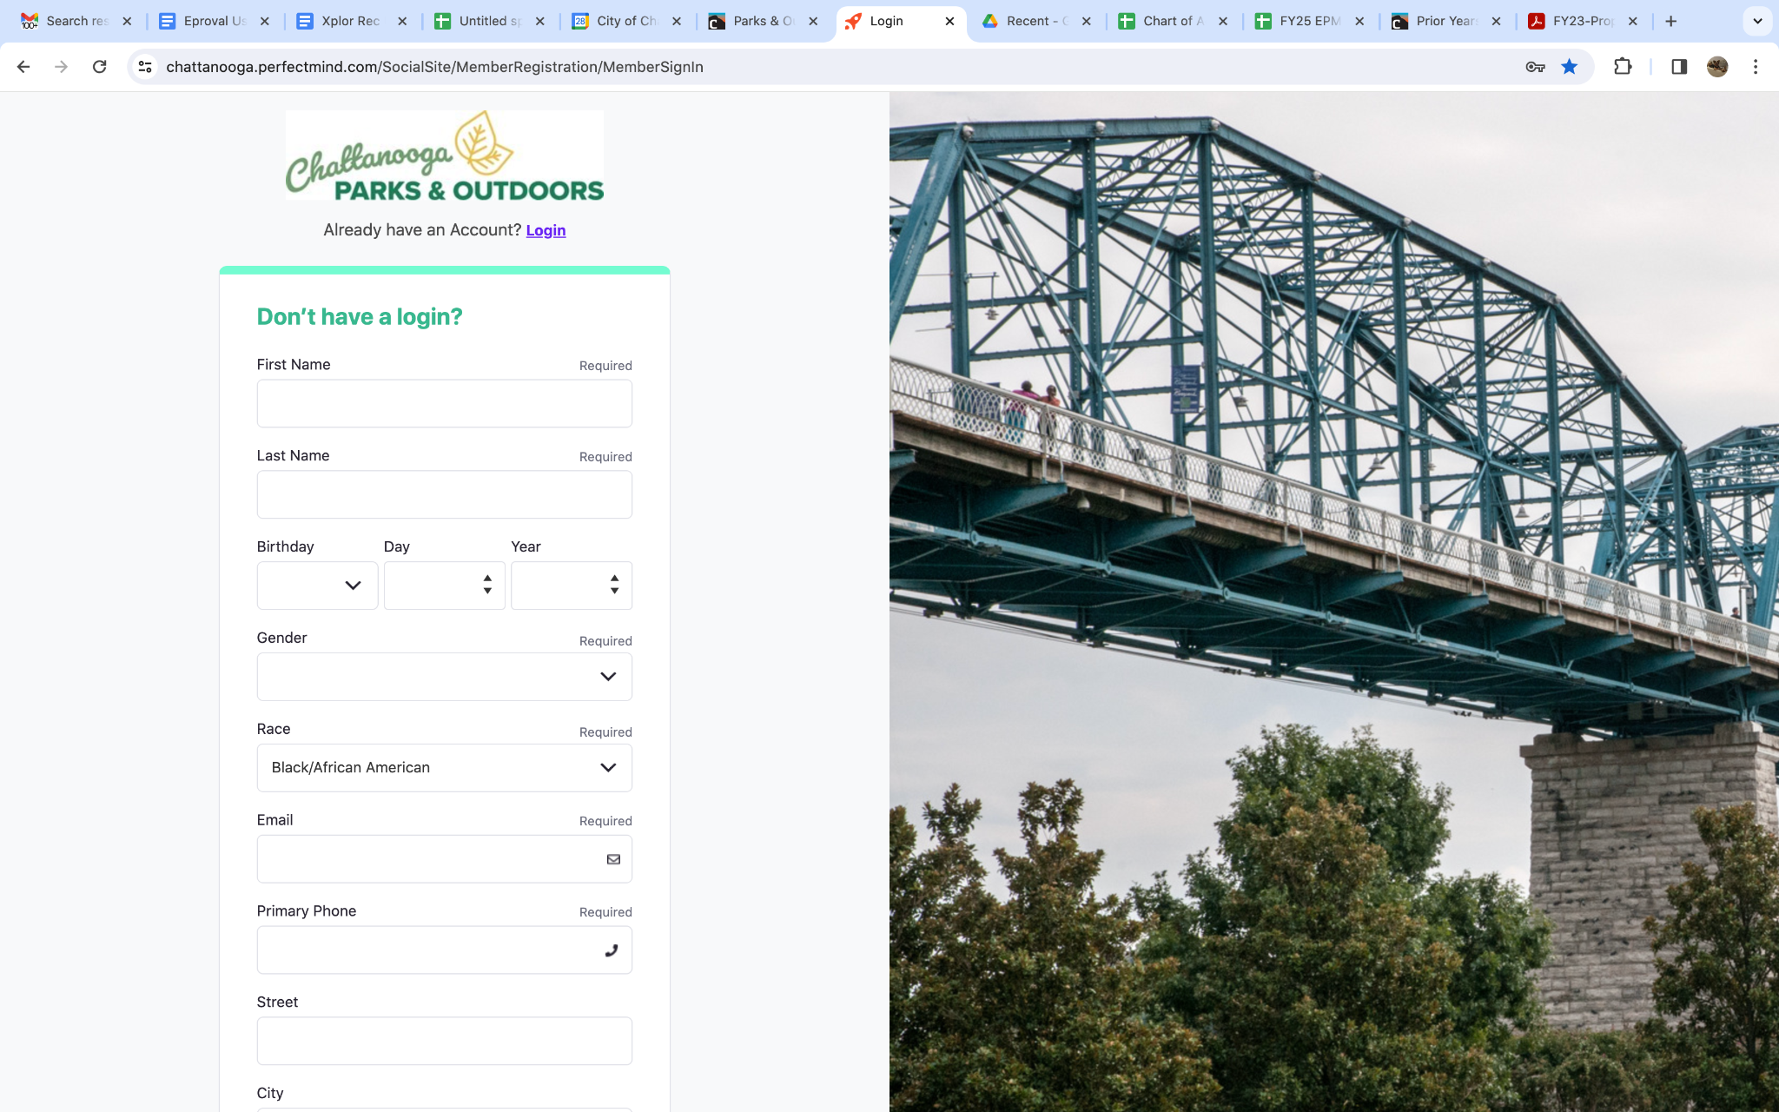

Xplor Rec Software User Manual

3. All new accounts will need to verify their email address. You will receive automatic email notifications. Follow the prompts of the email to verify your account. After your account is created, enter your email and password to login. If you ever forget your password, there is an option to reset.

Xplor Rec Software User Manual

4. Return to login page at chattanooga.perfectmind.com and login with username and password
5. Store your username and password for all registration and reservation needs for Parks and Outdoors.

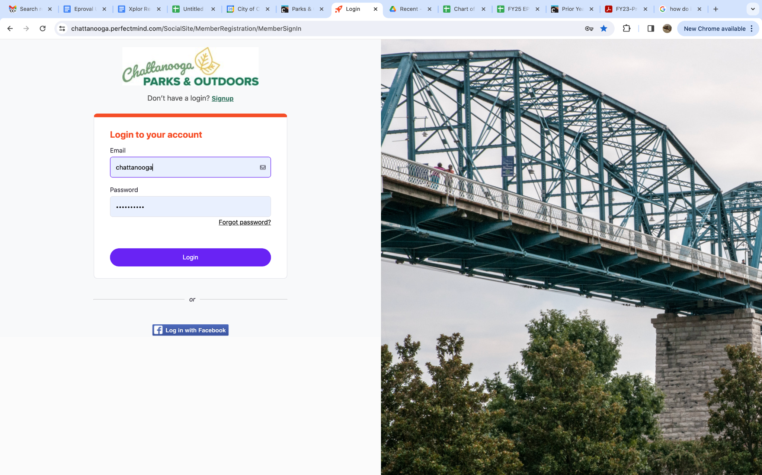

Xplor Rec Software User Manual

Dashboard

- Registration for Programs and Events Click on Activity Registration

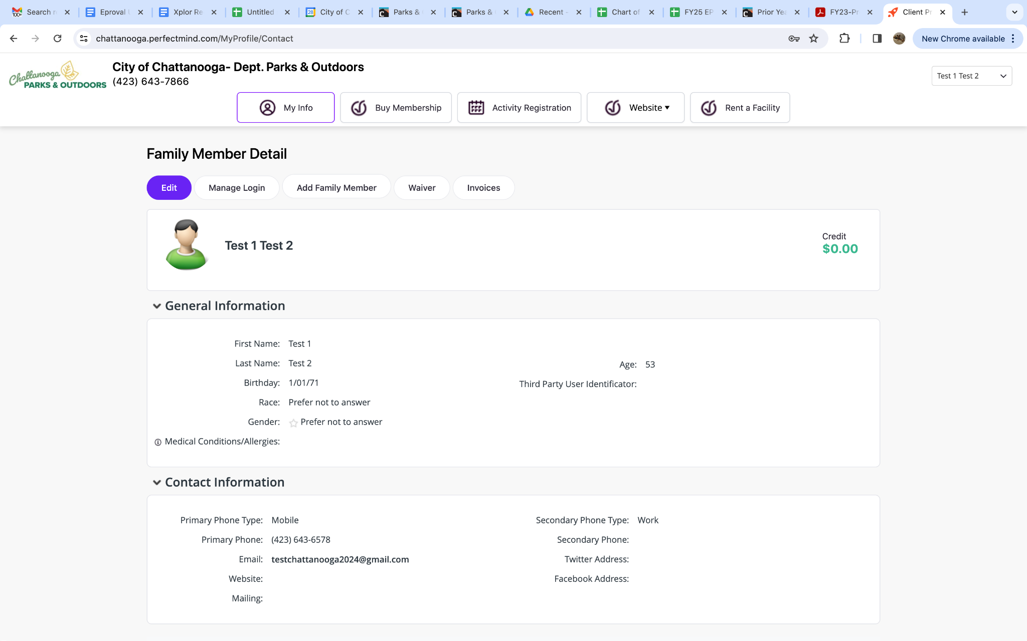

Xplor Rec Software User Manual

Dashboard

- Reservations for Parks, Ballfields, Pool Rental and Tennis Courts Click on Rent a Facility

Xplor Rec Software User Manual

Dashboard

- All participants MUST sign a Waiver Online. Click Waiver to read the Parks and Outdoors Liability Waiver and Sign.

If you have any questions please email DPOregistrations@chattanooga.gov and we will be happy to help you with all of your registration and reservation needs.

